**Hiera Example(puppet enterprise):**

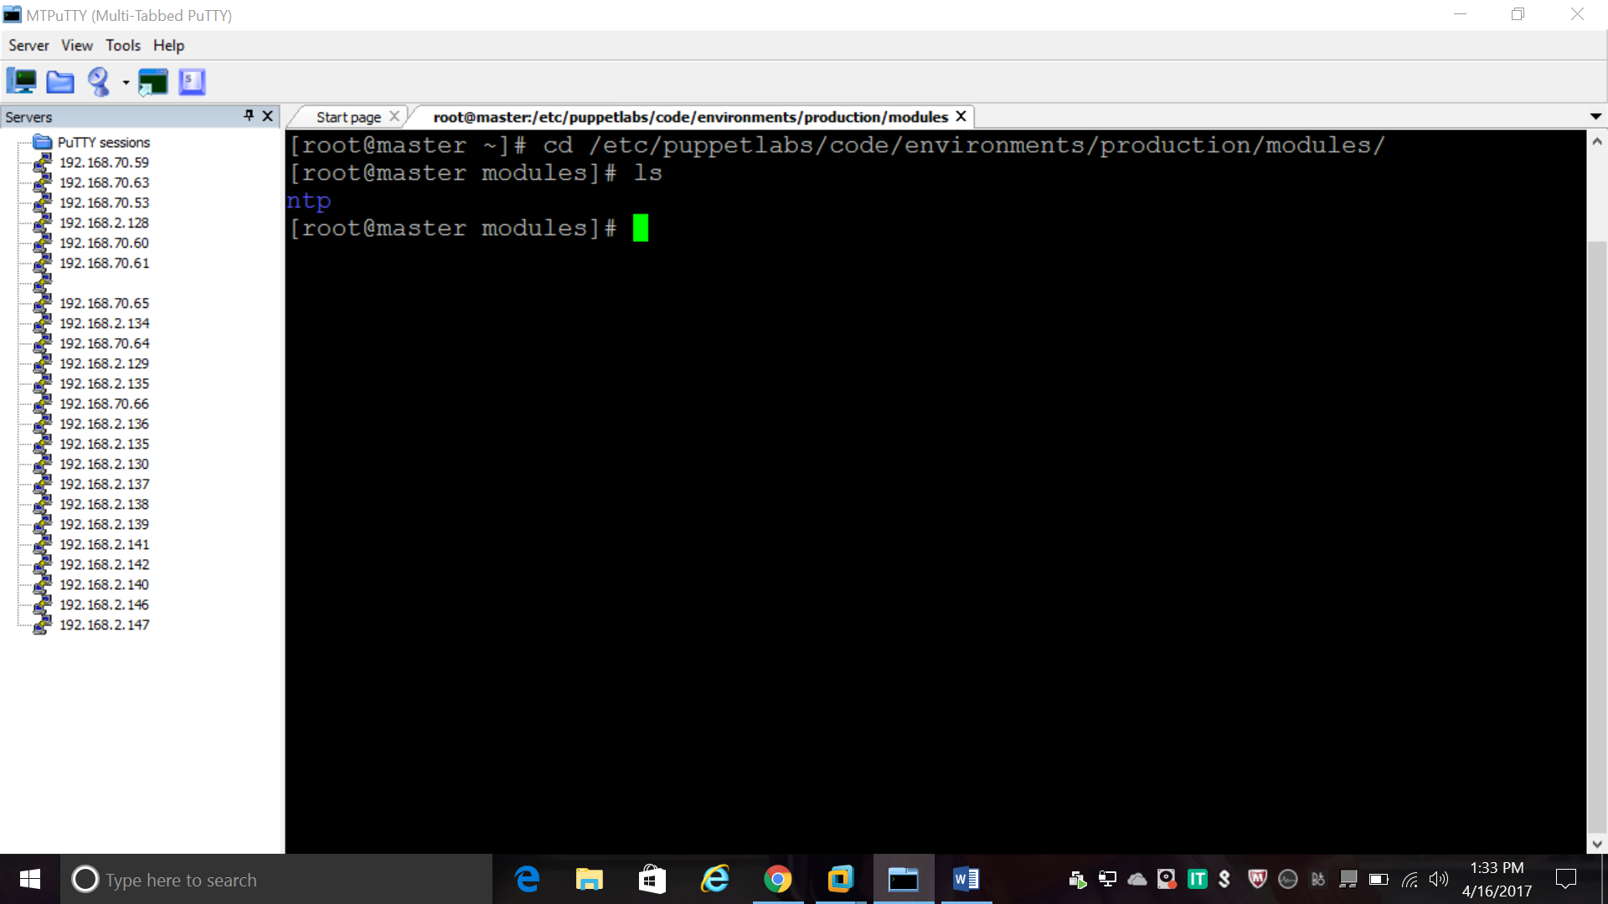

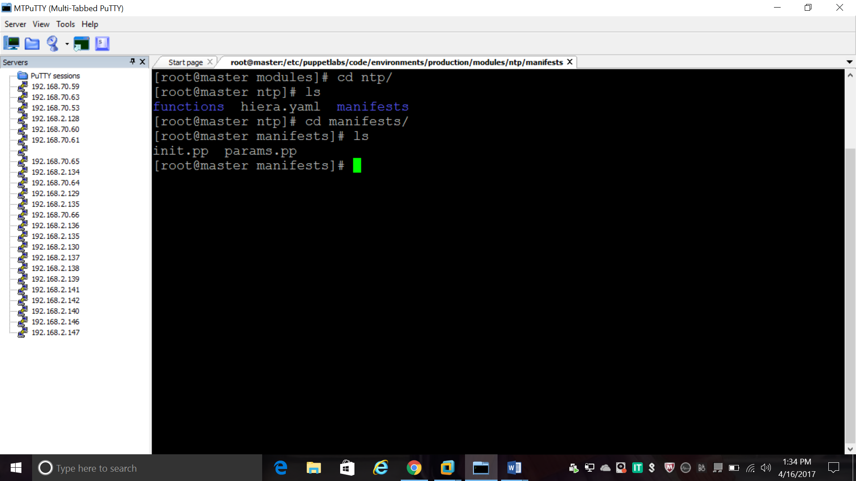

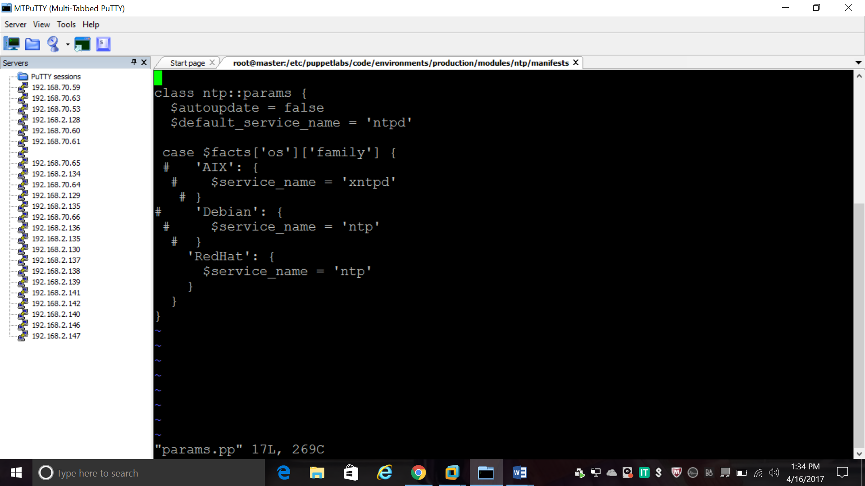

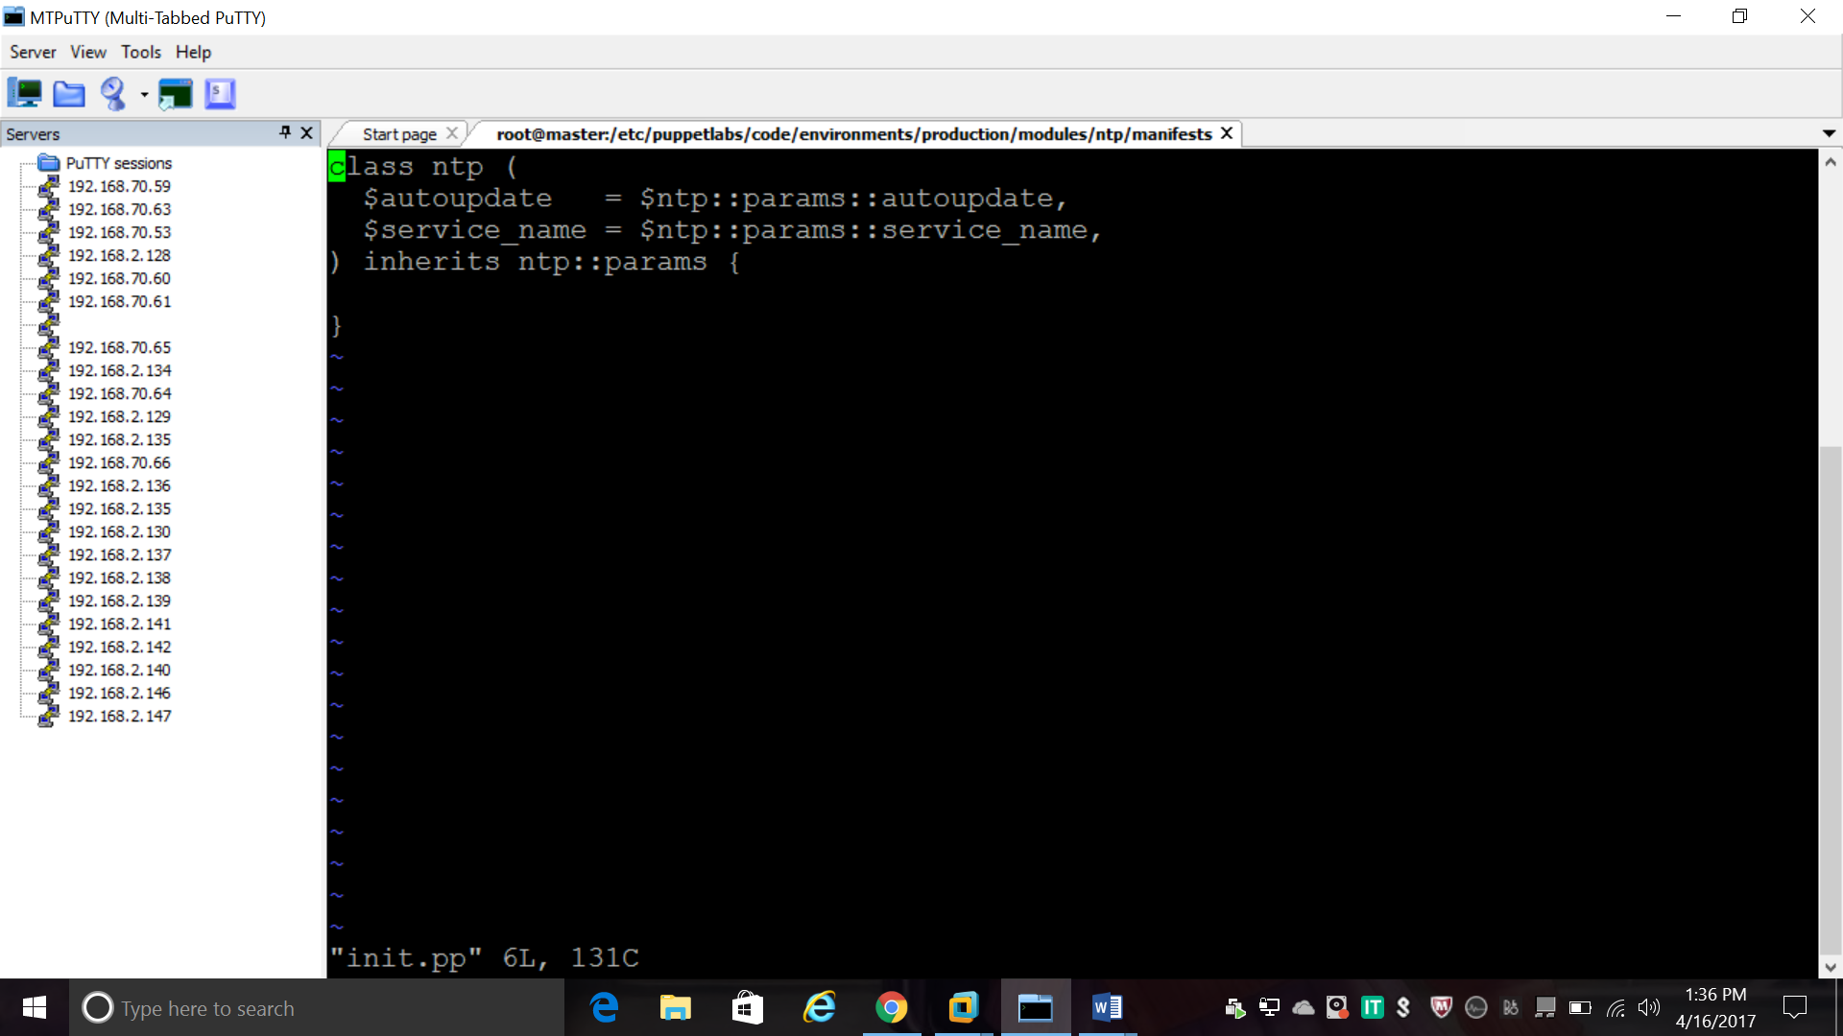

To create a Hiera backend, you need a Puppet function that returns a hash

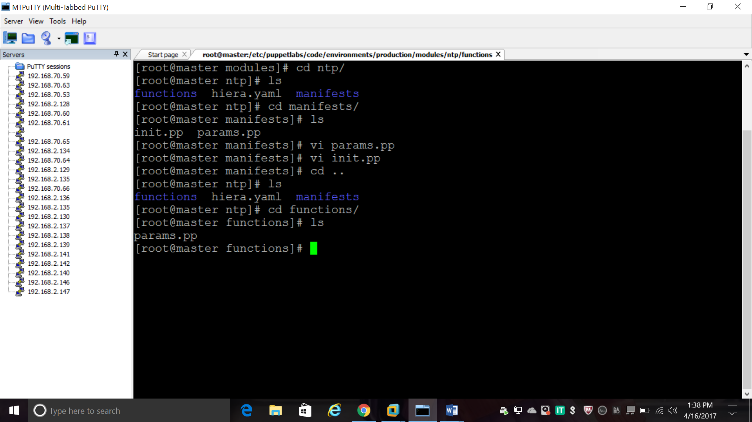

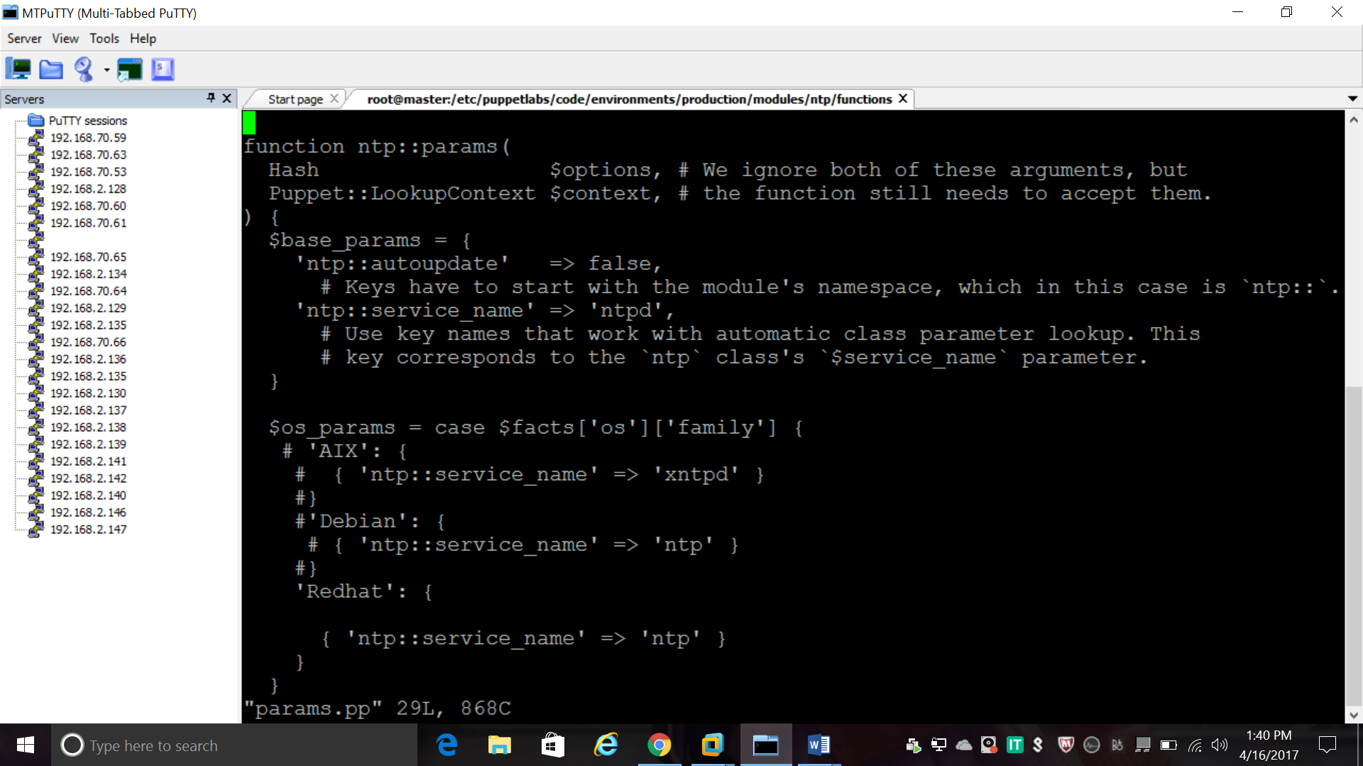

Once you have a function, tell Hiera to use it by adding it to the [module-layer hiera.yaml](https://docs.puppet.com/puppet/4.9/hiera_layers.html#the-module-layer).

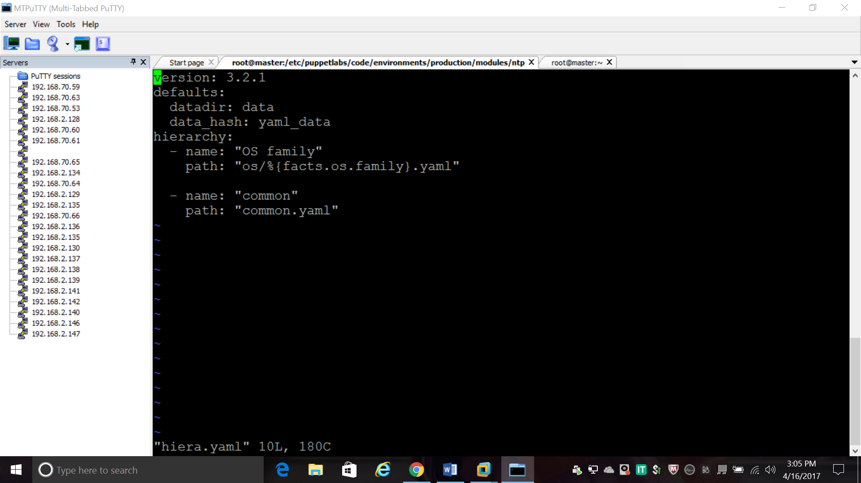

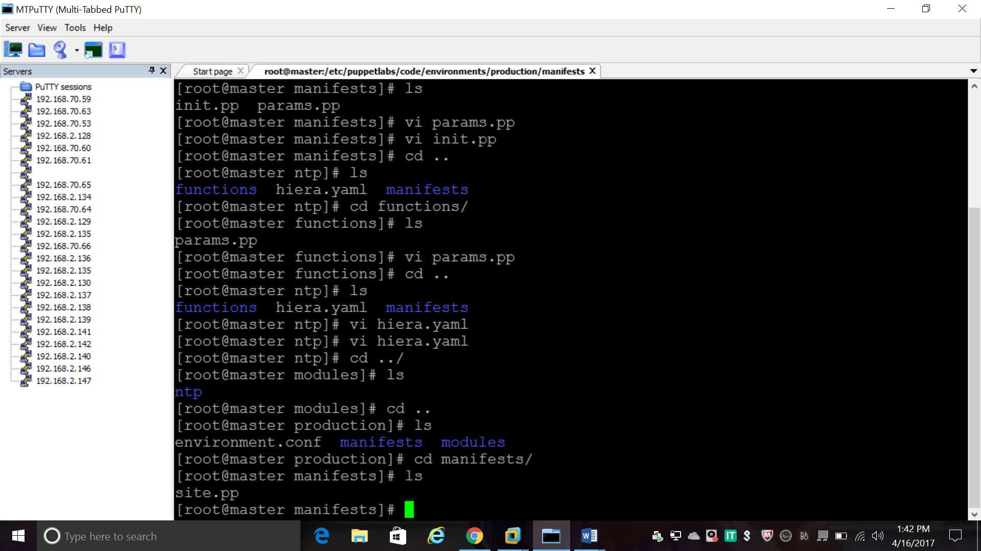

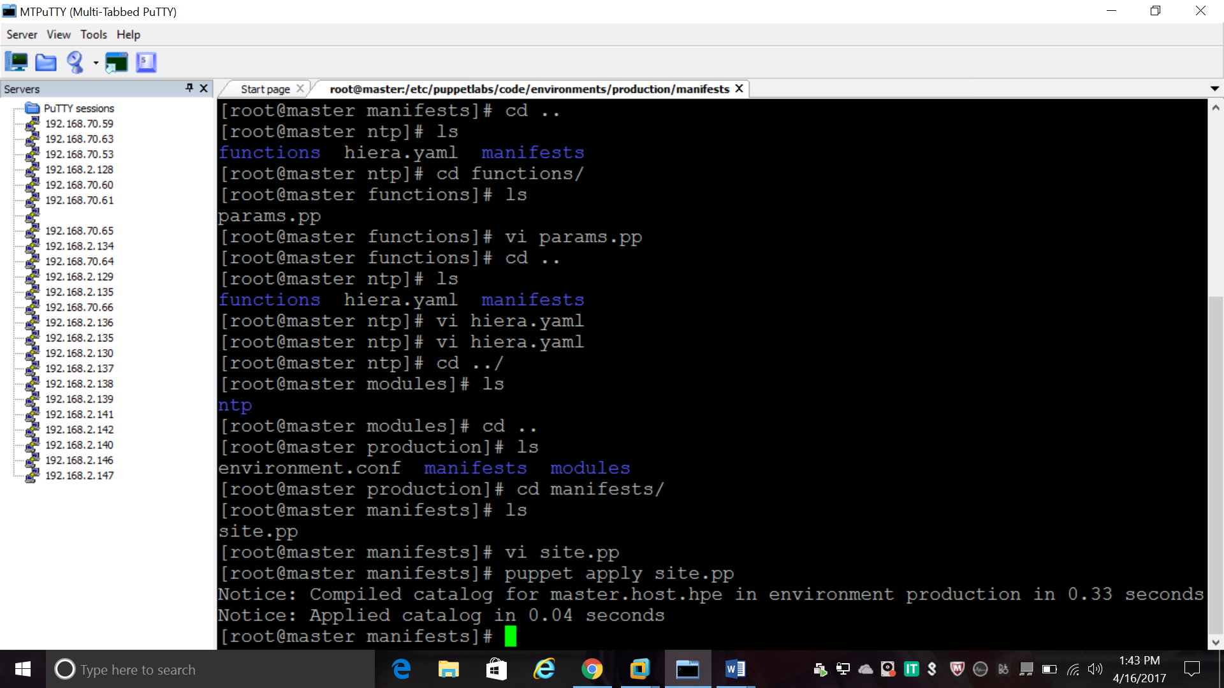

**INSTALLATION OF HIERA IN PUPPET:**

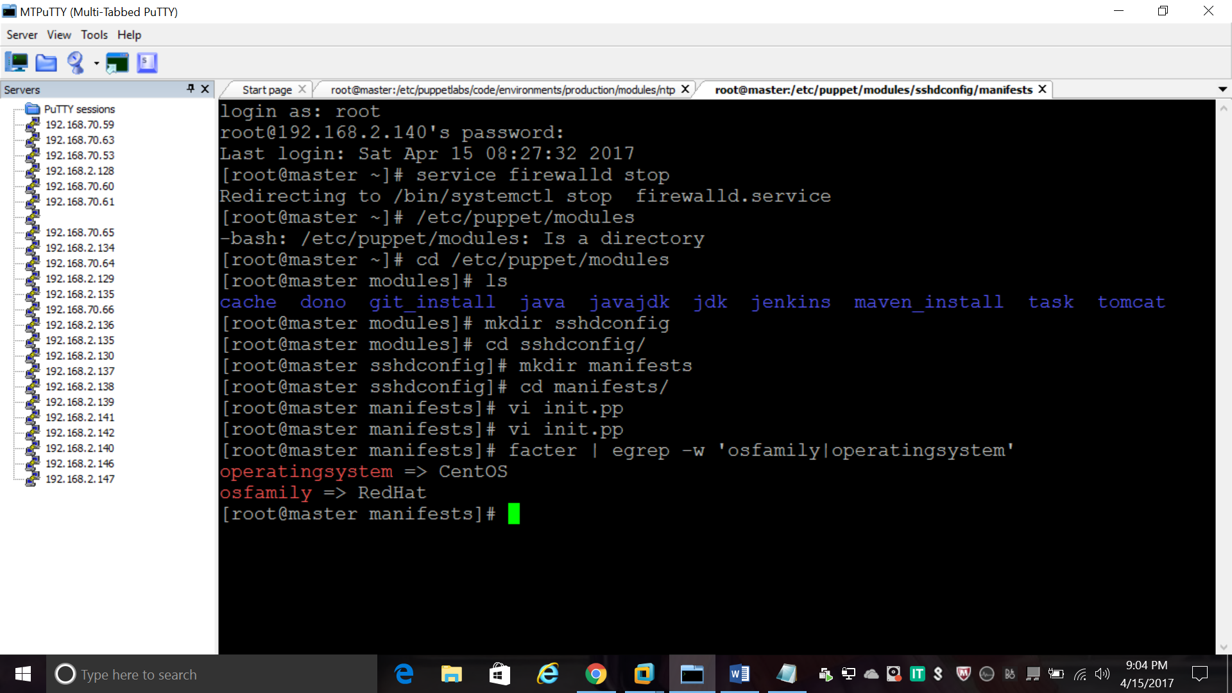

**#yum install hiera-puppet**

**#gem install hiera**

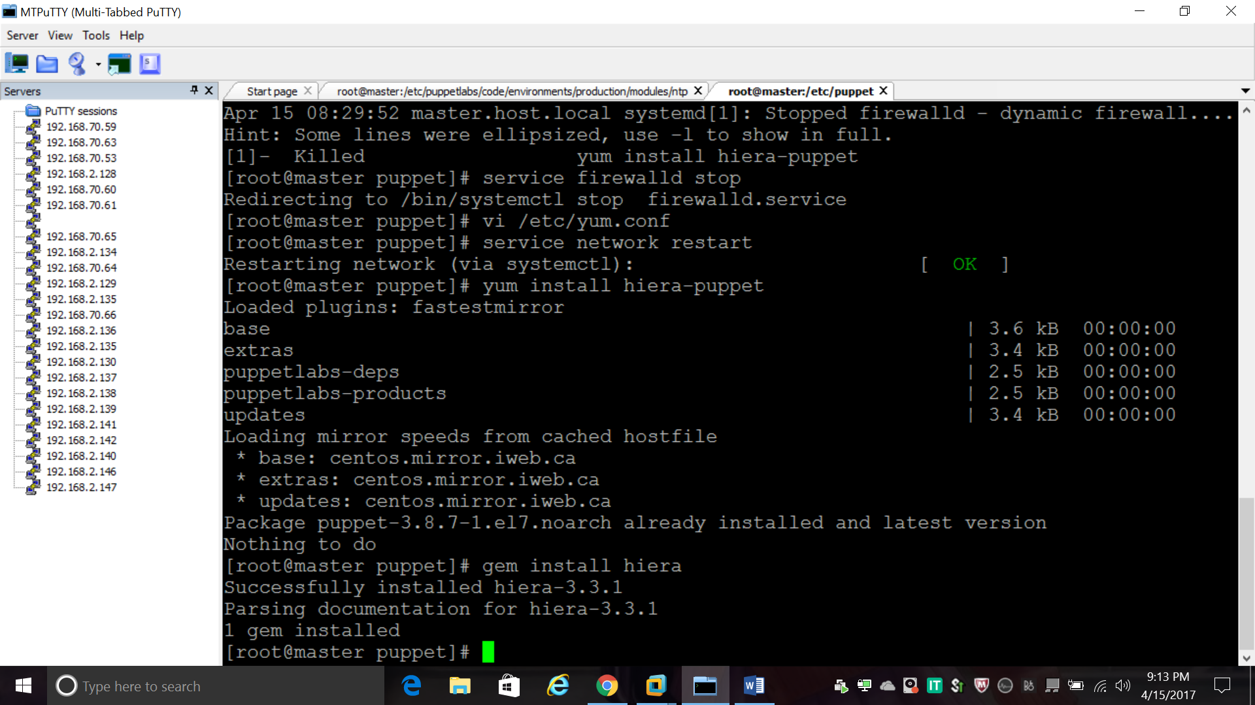

**Create config file on /etc/puppet**

**Vi hiera.yaml**

